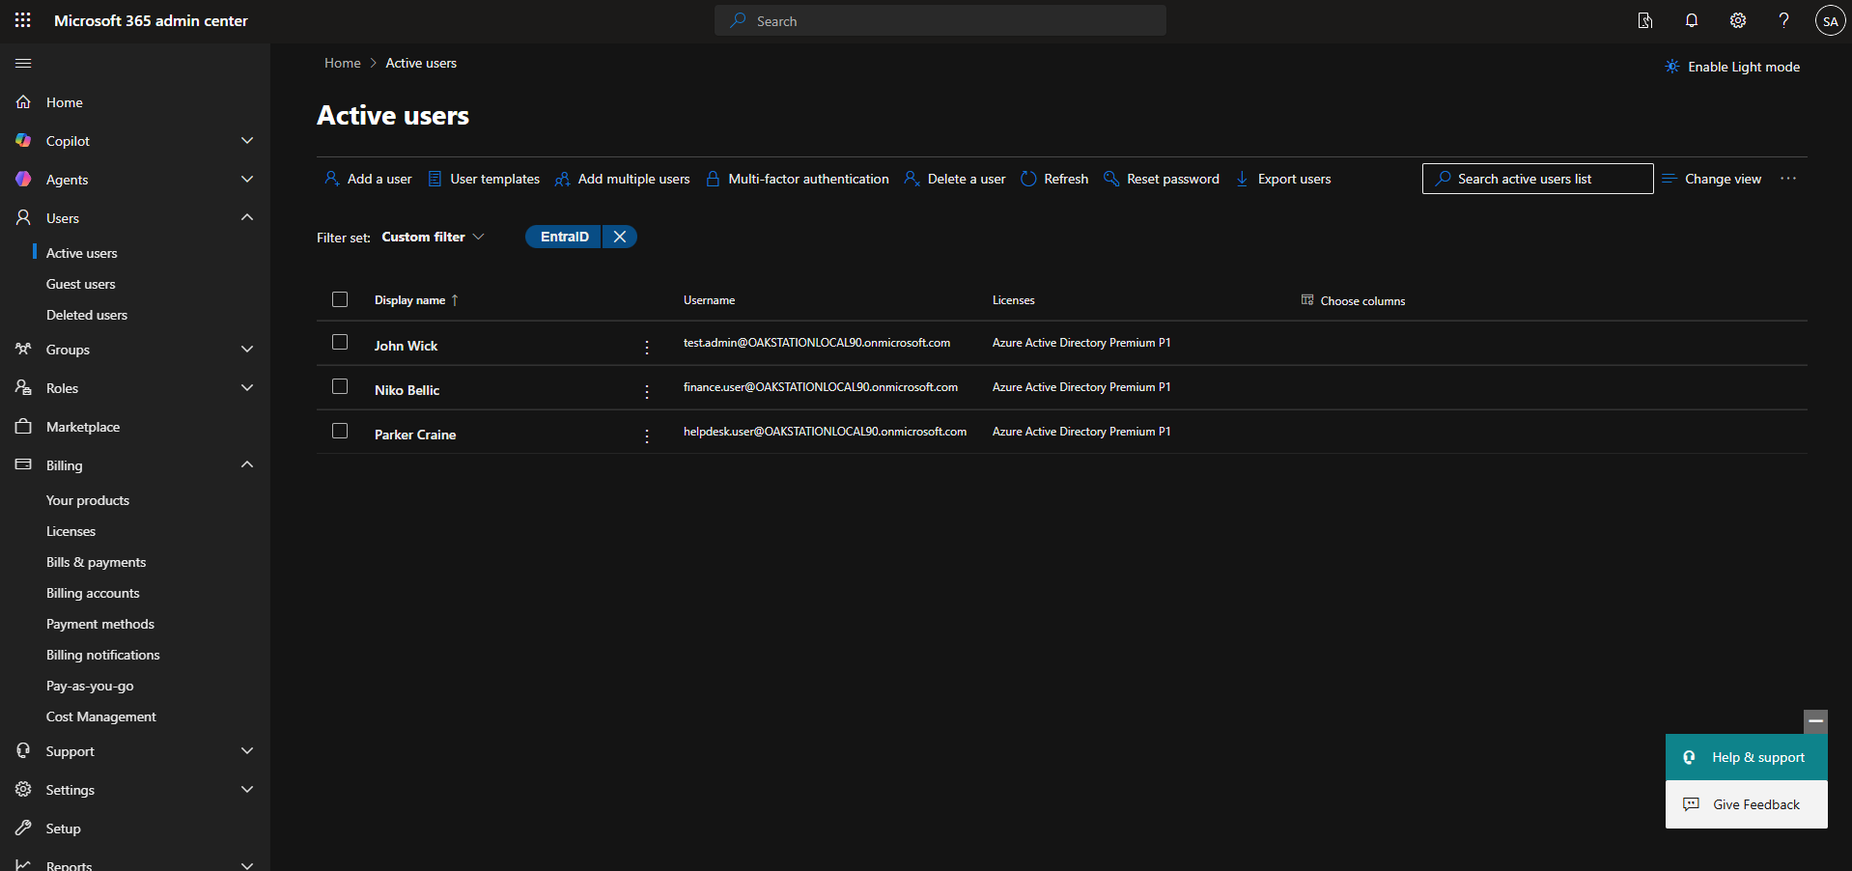
Step 1: User Creation and Initial Configuration
Created multiple user accounts within Microsoft 365 Admin Center to simulate a real organisational environment. Configured standard user accounts (helpdesk.user, finance.user) and an administrative account (test.admin) with appropriate roles. Assigned Azure Active Directory Premium P1 licenses to enable security features such as Multi-Factor Authentication (MFA) and Conditional Access.
This setup provides a foundation for simulating IT support scenarios, including user login issues, account management, and security policy enforcement.

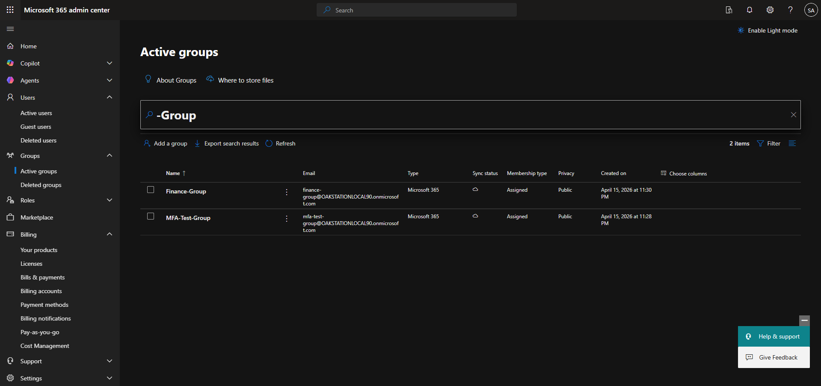
Step 2: Group Creation and User Assignment
Created security groups within Microsoft Entra ID to manage user access and apply security controls. Configured groups including MFA-Test-Group to enforce Multi-Factor Authentication and Finance-Group to simulate a departmental structure. Assigned users to appropriate groups and set group ownership to an administrative account (test.admin) to reflect real-world identity and access management practices.
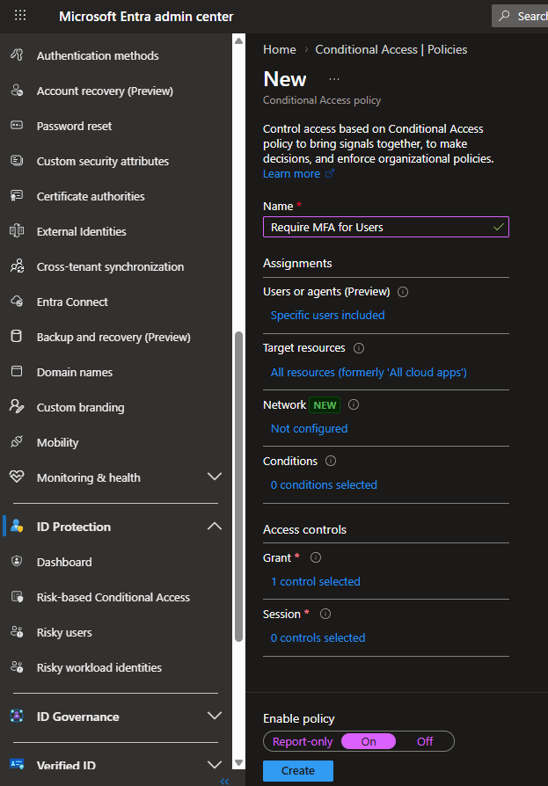
Step 3: Conditional Access Policy and MFA Enforcement
Configured a Conditional Access policy within Microsoft Entra ID to enforce Multi-Factor Authentication (MFA) for selected users. Applied the policy to the MFA-Test-Group, requiring MFA for access to Microsoft 365 applications. Tested user sign-in scenarios to validate policy enforcement, including successful MFA authentication and access restrictions, demonstrating secure identity and access management practices.

Scenario 1: MFA Enforcement via Conditional Access
Tested user sign-in after applying a Conditional Access policy requiring Multi-Factor Authentication for members of the MFA-Test-Group. Verified that the user was prompted for MFA and successfully authenticated. Confirmed policy enforcement through Microsoft Entra sign-in logs.
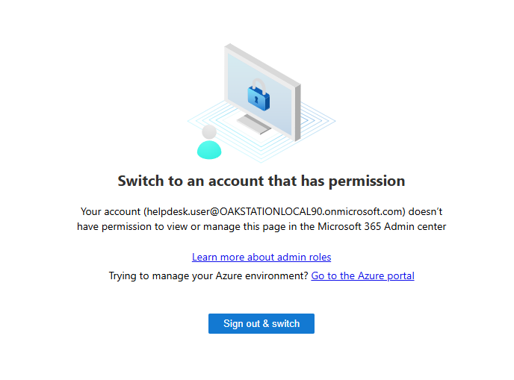
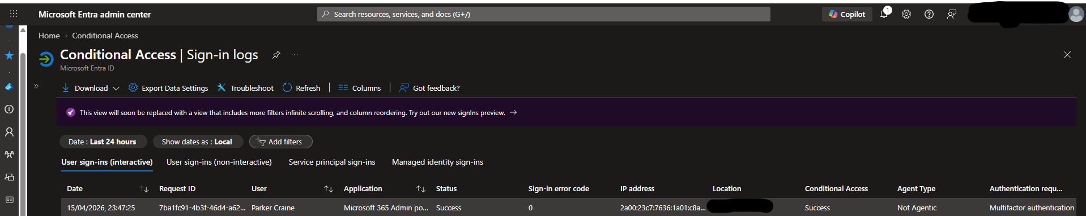

Scenario 2: Role-Based Access Control (RBAC)
Tested access to the Microsoft 365 Admin Center using a standard user account and confirmed that access was denied due to insufficient permissions. Demonstrated the principle of least privilege by restricting administrative access to authorised users only.
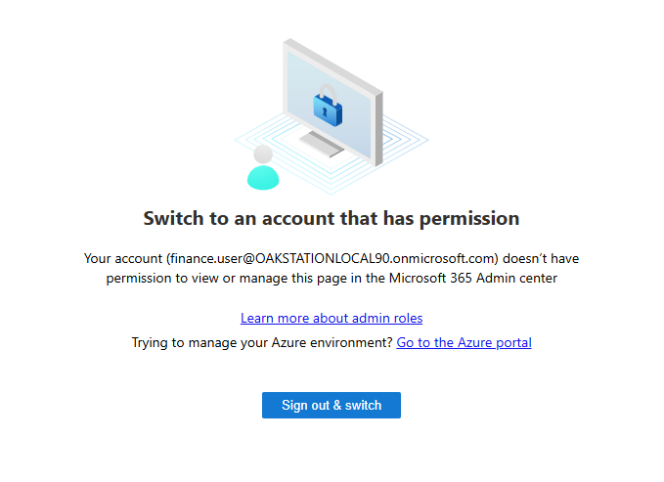

Scenario 3: Failed MFA Authentication
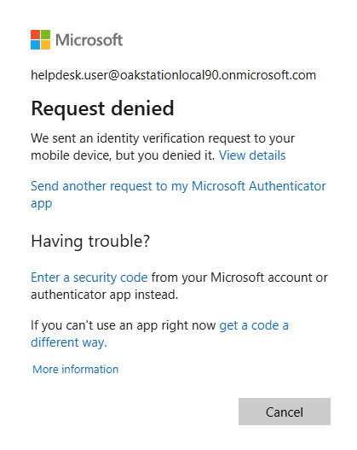
Simulated a failed login attempt by denying the Multi-Factor Authentication (MFA) request during sign-in. Observed that access was blocked despite correct credentials, demonstrating enforcement of Conditional Access policies. Verified the failed authentication event within Microsoft Entra sign-in logs.
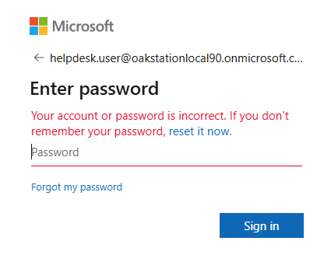
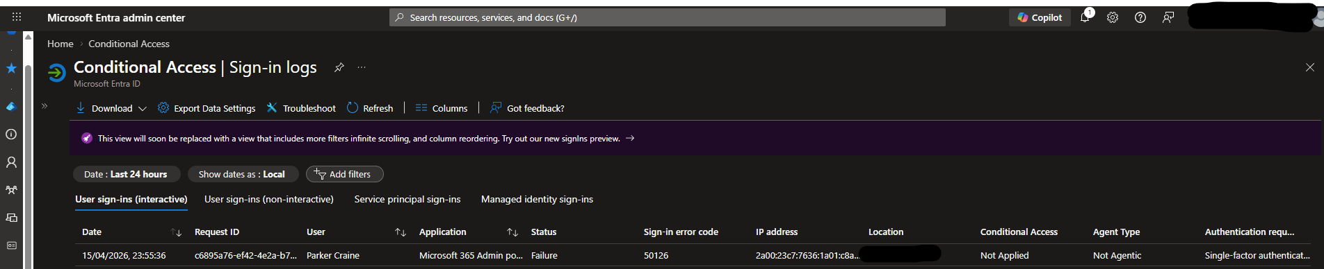

Key Outcomes -
- Successfully enforced MFA using Conditional Access policies
- Demonstrated role-based access control and least privilege principles
- Analysed authentication events using Microsoft Entra sign-in logs
- Simulated real-world IT support and security scenarios involving user access and authentication issues

